2nd April 2018

**YOKOHAMA Signs Partnership Agreement with US Major League Baseball’s Los Angeles Angels**

YOKOHAMA’s US sales and marketing subsidiary Yokohama Tire Corporation (YTC) signed a new partnership agreement with the US Major League Baseball (MLB) team the Los Angeles Angels. The new agreement is for the three seasons from 2018 through 2020 (including playoffs). According to the agreement, the YOKOHAMA logo will be displayed at the Angel Stadium, the Angels’ home stadium.   
  
YTC originally entered into a partnership with the Angels in 2011 as part of its effort to raise awareness of the YOKOHAMA brand in North America and contribute to local communities. The new three-year agreement extends the partnership with the Angels to a full decade. The Angels’ signing of Japanese two-way phenom Shohei Ohtani has focused even greater attention on the Southern California team and is expected to be widely covered by the media throughout the 2018 season.   
  
The Los Angeles Angels joined Major League Baseball as an expansion team in 1961 and have since gone on to win nine American League Western Division Championships, host three All-Star games and capture the 2002 World Series Championship. Over its 57-year history, the franchise also boasts four MVP’s, two Cy Young winners, two Rookie of the Year winners, 37 Rawlings Gold Glove winners and 154 All-Stars. Visit the Angels online at www.Angels.com, follow on Twitter @Angels and like on Facebook at www.facebook.com/Angels. For media information, visit www.angelspressbox.com.  
  
YOKOHAMA continues to support popular sports teams around the world as part of its efforts to raise its global brand recognition. In addition to extending its support for the Angels, the Company has been a proud sponsor of the Chelsea Football Club of English Premier League since July 2015. In Japan, YOKOHAMA sponsors the PRGR Ladies Cup golf tournament and supports the Team UKYO road cycling team.

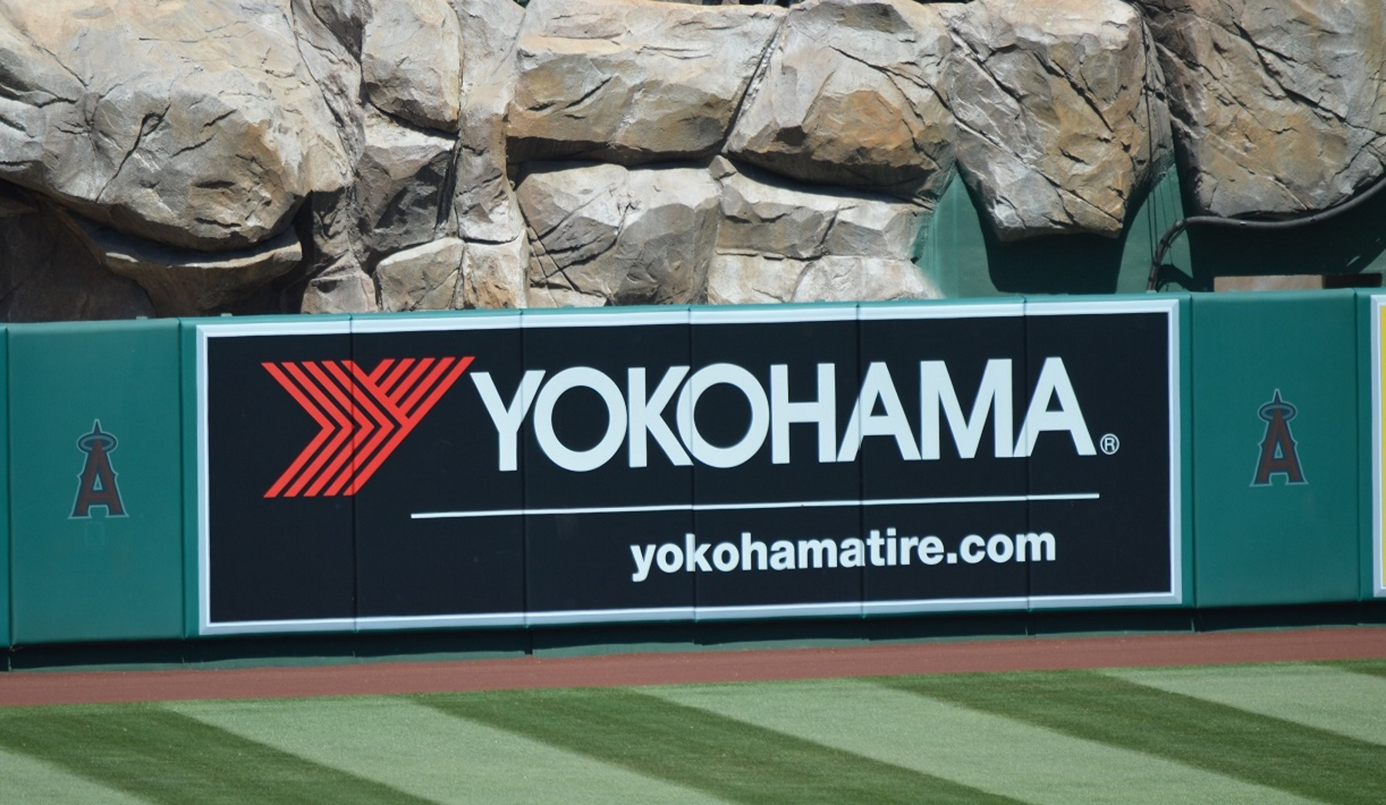

*YOKOHAMA's corporate advertising on the wall of Angel Stadium*

